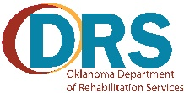
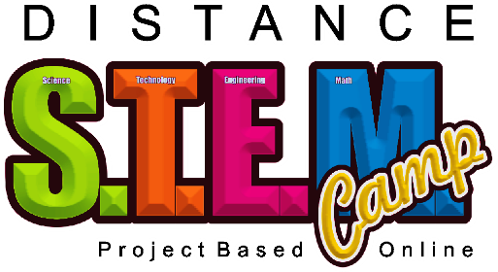
The DRS Distance STEM Camp is a no cost three-day camp.
Times: 10:00 a.m. to 2:00 p.m. Daily
Location & Dates: This is an online, project-based camp. Dates Will Be Announced As Camps Are Established.
Who? Open to all Oklahoma students with disabilities ages 14-18 (i.e., on an IEP, 504 Plan, or other documented physical, mental, or cognitive disabilities). Parents, guardians, and siblings are encouraged to support this learning experience by helping if needed, or wanted.
Requirements: Participants must have access to, and skills to use a computer, and inkjet color printer.
Must have a high-speed internet access point (lessons will be streamed online).
Must have a Gmail, email address (the address must end in .gmail.com (some project files may need to be emailed to Tech-Now Inc. for completion).
Must install Libre Office, Krita, and ZOOM on the computer being used (Windows – Mac- Linux computers, no Android Tablets or iOS Tablets supported).
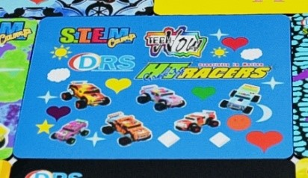
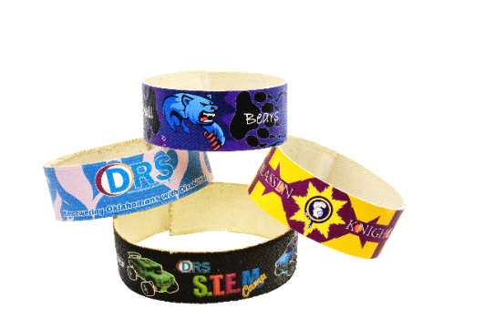
Must have a digital camera (can be a phone), and the ability to move pictures from the camera to the computer.
Must be able to use white glue, and E 3000 glue safely and appropriately.
Must be able to safely use scissors.
Must be able to safely use a household iron.
What: Learn to use computers, software, and related technologies to design and build an HT Gravity Racer.
Design and build a Dragster Power Racer.
Design and manufacture full color patches.
Design and manufacture a full color bracelet.
Design a full color T Shirt.
Design a full color mouse pad.
Design pin-back buttons.
You will create all of this using your computer, printer, and related technologies! Most importantly, you will develop technology skills that will last a lifetime!
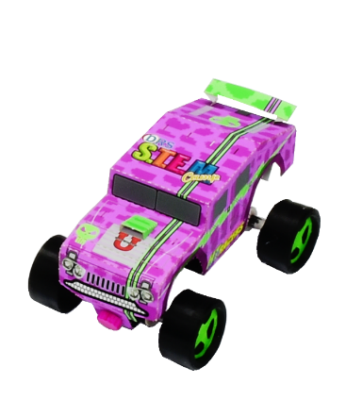
Contact Renee Sansom, rsansom@okdrs.gov ,at The Oklahoma Department of Rehabilitation Services for more information about the STEM Camp.
For information about Tech-Now email us at:
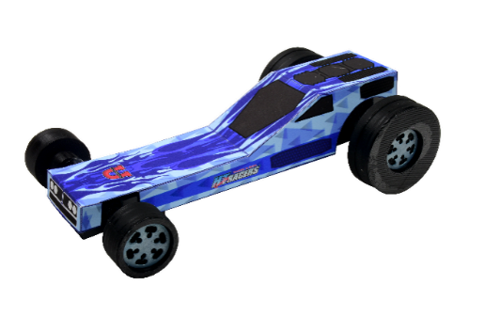
Tech-Now@hotmail.com

